Can you please change the following from Smooter look to Smoother look

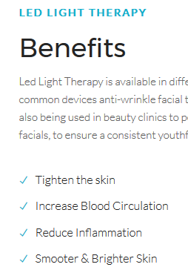

Under About LED light facial therapy section

Can you change from when you were in our 20’s to when you were in your 20’s.

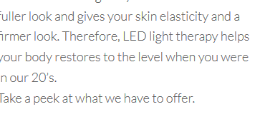

Under the About me Section

Can you change “and please with the decision” to “and pleased with the decision I made to take control of my life.”

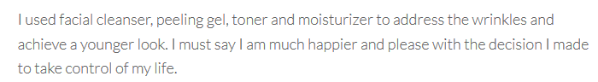

Also under About me Section, please remove “I hope this will help you to make an informed decision and take control of your life.”

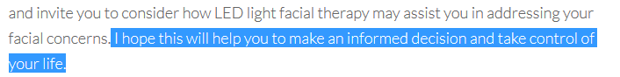

Under how it work section

Can you change it from “Meet new yourself” to “Meet Your New Self

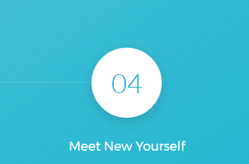

Can you change this picture. I attached the picture to email

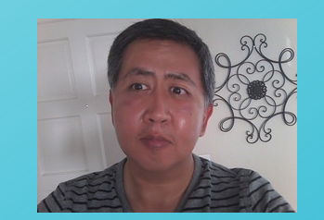

Can you make the phone number an option for the customers? The rest mandatory to enter

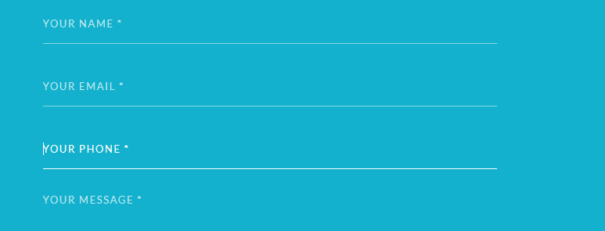

And it appears the link to send email to is broken. Please see below. I was thinking the email it should be associated to should be [TONY.ALVARADO@SKINLEDLIGHT.COM](mailto:TONY.ALVARADO@SKINLEDLIGHT.COM). You might have Tony.alvarado48@skinledlight.com

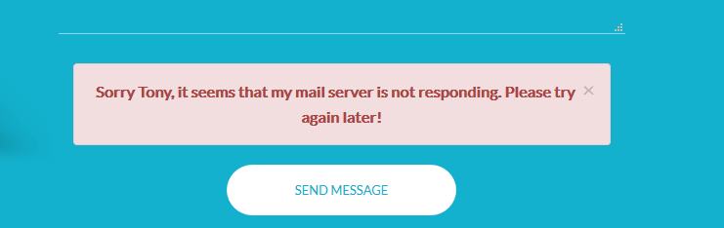

Final under Yellow Light products, I saw this. Can you correct this or remove it. I think what was there was LED mask product.

